**Casstown UMC**

**After School Program**

**First Wednesday of the month**

**September - May**

**2:30 pm to 4:30 pm**

Casstown United Methodist Church

102 Center St ● Casstown, Ohio

937-339-4828

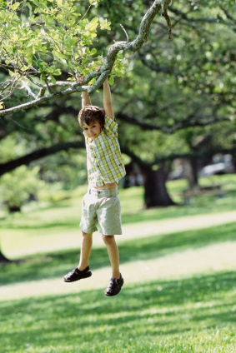

**Casstown UMC will be hosting an after school program during the school year. This FREE program will offer a snack, stories of hope, crafts, games and other activities, service projects, and more as well as an opportunity to work on homework with the help of local adults**.



**This after school program is for students in grades kindergarten to 5th grade. Sign up by sending this registration form back to the church (PO Box 203, Casstown, OH 45312). For more information, call the church office at 937-339-4828**

**Dates of the program include**:

September 5 October 3 November 7

December 5 January 2 February 6

March 6 April 3 May 1

**Casstown UMC -- After School Program**

**Registration Form**

**Please turn in registration to the Casstown Church Office**

**PO Box 203, Casstown, Ohio 45312**

Name: ___________________________Birthday: ____________________

Address:____________________________________________________

City: __________________________________ Zip Code:_____________

Age: ________________ Grade: ______________________

Siblings Attending:____________________________________________

Home Church:_______________________________________________

Home Phone:________________________________________________

Parent/Guardian Cell Phone: ____________________________________

Parent Email address: ________________________________________

Parent/Guardian Name:________________________________________

Emergency Contact Name:______________________________________

Emergency Phone:____________________________________________

Allergies (food etc.) or other Medical Conditions:_____________________

___________________________________________________________

Check One:

* I will drop off my child after school
* My child will walk from the bus stop on Main Street – Note: **Parents** must make arrangements with school bus department

Person(s) Picking Up: _________________________________________

By signing below I give my permission for my child to attend the after school program at the Casstown UMC and for Casstown UMC to use pictures of my child on their website, Church Facebook page or in news articles about the After School Program.

Parent Signature: ____________________________ Date: ____________